

**Macroeconomic Policy Responses in the UK**

Speech given by

David Blanchflower, Bruce V. Rauner '78 Professor of Economics, Dartmouth College, University of Stirling, IZA, CESifo, NBER and Member, Monetary Policy Committee, Bank of England

At the Globalisation and Economic Policy Centre, Nottingham University 29 January 2009

My thanks to Conall Mac Coille and Helen Lawton for assistance in preparing this speech.

1

All speeches are available online at [www.bankofengland.co.uk/publications/Pages/speeches/default.aspx](http://www.bankofengland.co.uk/publications/Pages/speeches/default.aspx)

*‘The only function of economic forecasting is to make astrology look respectable’*

*--John Kenneth Galbraith*

## INTRODUCTION

It is with great pleasure I come to the University of Nottingham. I’ve always been a big fan of Robin Hood and in today’s economic climate there has been no better time to take from the rich and give to the poor. It is well known that the marginal propensity to consume of those on low incomes is higher than those at the top of the income distribution. The Sheriff may not have appreciated the short-term stimulus some of Robin’s activities may have provided to Sherwood Forest and the Nottinghamshire economy.

In my last speech at Keynes College at the University of Kent on 29th October 2008 I argued that the UK had entered recession, the risks of inflationary pressure were benign and that monetary policy needed to be loosened quickly and sharply1. Since then it has become apparent an especially severe contraction in output and employment has taken place and is set to intensify in 2009. At the same time Bank Rate has been cut by 3.5 percentage points (pp) since September. The question facing policymakers now is how long and protracted the downturn may be, and what to do about it?

The outlook for the global economy has deteriorated rapidly. We are now faced with a synchronised downturn in most of the world’s major economies. These developments will have a profound impact on the UK economy and raise the prospects of an especially severe recession.

As an economy enters a recession many macroeconomic forecasters typically expect growth to return to its trend or average rate reasonably quickly. As economic conditions continue to deteriorate the projections for a recovery are successively pushed further out into the future. The common assumption appears to be that the underlying forces putting downward pressure on economic activity, which we often

1 D.G. Blanchflower (2009), 'Where next for the UK economy?', Scottish Journal of Political Economy, forthcoming, February

have a poor understanding of, are likely to dissipate. But often these shocks to economic activity are more prolonged than anyone expects. We must not be over optimistic.

Rather, we must allow ourselves to consider the possibility that the UK will experience a prolonged period of poor economic performance. Although it is a desirable expectation, there is little evidence to suggest this recession will be less painful than that in the early 1990s. Perhaps the current recession will be even more severe?

With Bank Rate at a historic low of 1.5% we must consider the options available to monetary policy makers in case we approach the zero bound in the near future. In this speech I will argue that the Bank of England has a range of tools available to provide an effective monetary stimulus to the economy, even at the zero bound.

## HOW BAD IS THE DOWNTURN SO FAR?

To understand how long and deep the current UK recession may be we need to understand when it began. The source of the current recession can be traced to the unsustainable rises in lending, bond, equity and house prices and compression of risk premia that have been evident since the start of decade across many developed economies. Indeed, the FTSE100 has fallen back to levels similar to those in 2003 and the Standard & Poors 500 share index had declined to its lowest level since 1997.

The current economic climate emerged from the bursting of these many bubbles, with the UK economy featuring prominently, but which started around the beginning of 2007 in the US sub-prime mortgage market. The global nature of the financial markets meant the re-appraisal of risk in the United States quickly reverberated around the world into other developed and developing economies.

When did the UK economy begin to contract? GDP growth was flat in 2008Q2 for the first time in 16 years and contracted in 2008Q3 by 0.6%, and by 1.5% in the final quarter of the year, the sharpest rate of decline since 1980. The *National Institute for*

*Economic and Social Research (NIESR)* calculates monthly estimates for UK GDP. These estimates indicate the recession began around May 2008.

In the United States recessions are dated by the National Bureau of Economic Research (NBER). The NBER indicate the US recession began in December 2007 when non-farm payrolls began to fall2. On that basis we can date the start of the UK recession as six months later as UK employment started to fall, quite sharply, from April 2008 (Table 1). Both ILO unemployment and the claimant count also started to rise in April 2008. Furthermore, private sector wage growth began to slow from its already benign levels, from around the spring of 2008.

There had also been a rapid slowing in a number of qualitative measures relating to the labour market from early 2008: the Chartered Institute for Purchasing and Supply (CIPS) employment surveys peaked in March, the Recruitment and Employment Confederation (REC) survey balance for permanent placements peaked in March and the British Chambers of Commerce (BCC) employment survey peaked in the final quarter of 2007 (see Charts 1-3). Together these employment surveys point to around April last year as the beginning of the recession.

What do the most recent data tell us about the near term outlook? A range of surveys measuring economic output fell through Q4 to historic lows. Industrial production declined by 6.9% in the year to November, the weakest annual growth rate since 1981. The Experian survey balance for activity in the construction sector fell to a record low in October. Similarly, the CIPS scores for activity in the manufacturing and services sectors fell very sharply to historic lows in Q4 (Chart 4).

However, the bad news doesn’t end there. Forward looking surveys suggest the severity of the recession will sharpen in 2009. The CIPS surveys for orders have fallen even more sharply than those for output. This is consistent with the GFK measure of consumer confidence which remains weaker than at any time since the survey began in the 1970s. Strikingly the BCC surveys of confidence in turnover have fallen sharply below any previous reading. These surveys provided a warning signal

2 <http://www.nber.org/cycles/dec2008.html>

that output was likely to contract in the 1990s recession. The Banks Agents’ scores for investment intentions in both the manufacturing and services sectors have fallen to lower levels than at any time since the surveys began in 1997 (Chart 5). In summary, the survey evidence indicates the contraction in UK GDP is likely to continue in 2009.

In the early 1990s recession, growth was initially supported by a relatively robust European economy. In part, this largely reflected the strength of the post-reunification boom in Germany. This time around many commentators had hoped that demand in emerging economies such as China could support global growth.

It is now clear a synchronised global downturn has begun. Investment and trade have slowed across both developed economies and emerging markets. Growth in the third quarter was negative in the United States, euro area and Japan, and survey evidence for these economies indicates that the pace of contraction is likely to accelerate in the fourth quarter.

In Germany, provisional estimates indicate calendar year GDP growth was 1.3% in 2008, implying the economy shrank by around 1.5% to 2.0% in the final quarter. Euro area industrial production had fallen by 3.1% in the three months to November, the largest decline since the series began in 1990. The euro area manufacturing and services purchasing manager indices (PMIs) fell to historic lows in December, and remained at similar levels in January. So the contraction in euro area output is likely to accelerate sharply in 2008Q4 and continue in 2009Q1.

The deterioration in US economic conditions has been staggering. In December, non- farm payrolls fell by 524,000 on the month, and have fallen by over 1 million since October. In the year to December US manufacturing output had suffered its largest decline since 1975. The output and new orders subcomponents of the Institute for Supply Management (ISM) survey are at their lowest level since 1950. Developments in the construction and housing markets remain bleak. In December the number of newly started dwellings and newly authorised construction permits fell to an all time low since the series were first recorded in 1959.

It is now clear that growth is receding in the Asian economies. GDP growth in China has fallen to it lowest level since 2001 and the growth of industrial production is at the lowest level since 19953. In the fourth quarter GDP in South Korea and Singapore fell by 5.6% and 4.4% respectively. In December, nominal Japanese exports had fallen by an astonishing 35.0% on the year. It is clear that the Asian economies are unlikely to sustain global demand going forward.

The synchronised nature of the current downturn should not be too surprising. We do not live in a decoupled global economy. Rather, economies are now more greatly integrated through trade and financial market linkages than in the past. And deteriorating financial market conditions are hitting the developing economies too. Sharp declines in international bond issuance by, and syndicated loans to, emerging market firms has cast doubt on their ability to maintain capital spending. The flow of credit is reported to have dried up in several countries given the risk of lending as international trade shrinks.

The slowdown in world demand is having a clear dis-inflationary effect. Input costs and output price inflation have fallen back across many economies. Crude oil, commodity prices and the cost of shipping raw materials have fallen precipitously. The Baltic Dry index, a measure of shipping costs for raw materials, has fallen by around 95% since its peak in May. According to shipping journal Lloyd's List ‘*brokers in Singapore are now waiving fees for containers travelling from South China, charging only for the minimal "bunker" costs. Container fees from North Asia have dropped $200, taking them below operating cost.*’

At the same time measures of consumer price inflation have declined. In the euro area annual HICP has fallen from a peak of 4.0% in July to just 1.6% in December, US annual CPI inflation has fallen from a peak of 5.6% in July to 0.1% in December. The fall in US CPI inflation, coupled with the broader deterioration in the economic outlook, has prompted significant macroeconomic policy responses. The US Federal Reserve has cut interest rates to close to the zero bound and President Obama’s administration has planned a substantial fiscal stimulus.

3 Excluding holiday months.

In its most recent projections published yesterday the *International Monetary Fund* (IMF) now expects world GDP growth to be just 0.5% in 2009. The US economy is expected to contract by 1.6%, euro area by 2.0% and UK by 2.8% in 2009. If realised these projections would constitute the slowest level of world GDP growth, and biggest contraction of the UK economy, since World War 2.

Even without the rapidly deteriorating domestic outlook, the slowdown in the world economy would pose a stern challenge for the UK. Given that UK output and employment have already started to contract, the lack of support from external demand suggests the UK recession will be all the more severe.

## WHAT CAN WE LEARN FROM PAST RECESSIONS

The last two recessions occurred in the early 1990s and 1980s. During these periods GDP contracted for five successive quarters, and it took over three years for output to gradually recover to its pre-recession level (Chart 6). So if past recessions are any guide UK GDP is likely to continue contracting until at least the second half of 2009.

Previous recessions have varied substantially in the severity and duration of their effects on the labour market. The unemployment rate rose for four years following the first oil shock in the early 1970s, from 3.4% to 5.7% and by 5.5pp between 1980 and 1982, remaining in double figures until 1987. The unemployment rate rose for 3 years in the early 1990s rising by 3.8pp and only fell back to its pre-recession level by the end of 1997. So the current deterioration in labour market conditions is likely to persist for the foreseeable future.

Past recessions may have led to adverse effects on the supply potential of the economy. Long-term unemployment, particularly at a young age, is damaging to future labour market prospects both for the individuals involved and the economy as a whole. Workers may lose their skills, causing a loss of human capital. High rates of unemployment may mean there is a mismatch between those skills that workers possess and those for which there is demand within the economy. People may also be less likely to participate in the labour market the longer their spell of unemployment persists.

Sustained unemployment while young, especially of long duration, has particularly nasty effects. By preventing labour market entrants from gaining a foothold in employment sustained youth unemployment may reduce their productivity. A range of evidence indicates those that suffer youth unemployment have lower incomes and poorer labour market experiences decades later4. These are important lessons for any measures that may be taken to address higher unemployment in the near future.

Thus far, there has been little increase in long-term unemployment. But this problem may emerge as the downturn becomes more acute. Worryingly, unemployment of those aged 18-24 years increased by 55,000 in the three months to November, around 40% of the total increase in unemployment over the same period.

One feature of recessions is that macroeconomic forecasters fail to appreciate their length and depth. Chart 7 illustrates the real-time Consensus forecasts for UK GDP growth in each calendar year over the period around the time of the last recession5. Here, each line illustrates a stream of forecasts for GDP growth in a particular calendar year. The x-axis illustrates the point in real time when each projection was made, and the y-axis the projection itself6.

So the very first point in the pink line indicates that the first forecasts for 1991, which were made at the beginning of 1990, were for growth of around 2%. But over time these forecasts were revised down, eventually to around -2%. And even when UK output was expected to contract by around 2% in 1991, economic forecasters still expected growth to recovery quickly in 1992.

Institutions have proved little better at anticipating economic slowdowns. Charts 3 and 4 illustrate a broadly similar pattern of forecast revisions from the Organisation for Economic Co-Operation and Development (OECD) and NIESR projections. There was no mention at all of the word 'recession' in the Monetary Policy Committee's

4 See P.A. Gregg and E. Tominey (2005), 'The wage scar from male youth unemployment', Labour Economics, 12, pp. 487-509 or W. Arulampalam (2001), 'Is unemployment really scarring? Effects of unemployment experiences on wages'**,** *Economic Journal*, **(**111), November, pp: F585-F606.

5 The Consensus projections are the average of a survey of private sector macroeconomic forecasters.

6 The pink cross indicates the first data out-turn from the ONS for calendar year GDP growth in 1991, and the dot the most recent data.

August 2008 *Inflation Report*. The central projection was for output to be "*broadly flat over the next year or so, after which growth gradually recovers*" (p.5).

Perhaps economists tend to under-predict the magnitude of recessions because the underlying adverse shock to economic activity is assumed to have largely run its course. This leads macroeconomic forecasters to expect growth to gradually recover towards its trend or average rate at any given time. Few forecasters expect the adverse influences on economic activity, and the responses of households and firms to them, to intensify.

This is understandable as we do not possess a good understanding of the forces that drive cyclical upturns and downturns, the ‘animal spirits’ as Keynes referred to them. Of course, many economists would attribute their forecast errors to apparently unprecedented events that cause economic prospects to deteriorate rapidly. For example, the accounting scandals in early part of this decade or the collapse of Lehman Brothers investment bank.

That these unexpected events happen so regularly, particularly within the financial sector, has not led us to anticipate them more frequently. Furthermore, there appears to be confusion between cause and effect. The collapse of Lehman Brothers was clearly the result, not the cause, of the deterioration in the US sub-prime housing market and the deterioration in global financial market conditions.

Of course, economic output in the UK, and in many other economies, had started to contract long before the collapse of the Lehman Brothers investment bank. Perhaps the significance of this event was that it brought forward a realisation and acceleration of the necessary adjustment within the financial sector.

In summary, if past recessions are any guide they suggest the current contraction in UK economic activity is likely to continue for some time with output recovering only gradually thereafter. A key lesson for macroeconomic policy makers is that there is a danger of under estimating the length and depth of the recession. We must consider

the policy options to address the plausible possibility that the UK will now experience a recession as severe as the one that hit the UK so hard in the early 1980s.

## WHAT DOES ECONOMICS TELL US?

In considering the likely causes, magnitude and persistence of the current recession and the appropriate monetary and fiscal policy responses, I would have liked to offer you some insightful observations from the cutting edge of modern macroeconomic research. It may surprise non-technical economists that the standard assumption in economic research is that the financial sector has priced all assets efficiently at all times in the past, and will continue to do so over the infinite future. In fact, for all intents and purposes the financial sector barely exists or is omitted from many economic models. It is as if developments in the financial sector only had an impact on the economy in a crude distant past, such as the 1930s or 1970s, in which neither money markets nor monetary policy were properly understood.

Hence, it is a sad indictment of the economics profession that few macroeconomists actually spotted the greatest financial crisis in a hundred years. Rather, many macroeconomists believed such a possibility was highly unlikely, in fact we had apparently entered a period of ‘great stability’, and research priorities have been shaped accordingly. The1995 Nobel Laureate Robert E. Lucas Jr. in his presidential address to the American Economic Association states,

"Macroeconomics was born as a distinct field in the 1940's, as a part of the intellectual response to the Great Depression. The term then referred to the body of knowledge and expertise that we hoped would prevent the recurrence of that economic disaster. My thesis in this lecture is macroeconomics in this original sense has succeeded: its central problem of depression prevention has been solved, for all practical purposes, and has in fact been solved for many decades". R.E. Lucas, The American Economic Review, March 2003, pp. 1-14.

The 2008 Nobel Laureate Paul Krugman noted in the *New York Times* on January 4th, 2009, citing the Lucas quote above.

"We weren't supposed to find ourselves in this situation. For many years most economists believed that preventing another Great Depression would be easy... It turns out, however, that preventing depressions isn't that easy after all. Friedman’s claim that monetary

policy could have prevented the Great Depression was an attempt to refute the analysis of John Maynard Keynes, who argued that monetary policy is ineffective under depression conditions and that fiscal policy

— large-scale deficit spending by the government — is needed to fight mass unemployment. The failure of monetary policy in the current crisis shows that Keynes had it right the first time".

Some economists have celebrated the triumph of economic theory in modern macroeconomic research.

“Over the last three decades, macroeconomic theory and the practice of macroeconomics by economists have changed — for the better. Macroeconomics is now firmly grounded in the principles of economic theory.” Chari and Kehoe (2006).7

I disagree that this is an improvement. Macroeconomics has had little to say about the current astonishing events in the financial markets and global economy. Macroeconomic research and theory should principally be concerned with explaining events in the real world, not vice versa. Fortunately I am in good company. Nobel Laureate Robert Solow, for example, has recently criticized the ‘state of macro’ because it is not well grounded in the data.8

“The other possible defence of modern macro is that, however special it may seem, it is justified empirically. This too strikes me as a delusion. In fact “modern macro” has been notable for paying very little rigorous attention to data. I am left with the feeling that there

is nothing in the empirical performance of these models that could come close to overcoming a modest scepticism. *And more certainly, there is nothing to justify reliance on them for serious policy analysis*”. Solow, 2008, p.245 (our italics).

Perhaps, the best I can offer you is an event analysis of past financial market crises by Reinhart and Rogoff (2009) who find that financial crises have "deep and lasting effects on asset prices, output and employment".9 More often than not, they argue, the aftermath of severe financial crises share three characteristics. First, asset market collapses are deep and prolonged. Real house prices decline on average by 35% over

7 V. V. Chari and P. Kehoe (2006), ‘Modern macroeconomics in practice: how theory is shaping policy’, Journal of Economic Perspectives, Fall, pp. 3–28.

8 R. Solow (2008), ‘The state of macroeconomics’, Journal of Economic Perspectives, 22(1), Winter,

pp.243–249.

9 C.M. Reinhart and K.S. Rogoff (2009), 'The aftermath of financial crises', NBER Working Paper

#14656.

a period of six years, while equity prices fall on average by 55% over a period of three and a half years. Second, the unemployment rate rises on average by 7 percentage points over the down phase of the cycle, which lasts on average over four years. Output falls (from peak to trough) on average by over 9%, although the duration of the downturn, averaging roughly two years, is considerably shorter than for unemployment. Third, the real value of government debt tends to explode, rising on average by 86% in the major post–World War II episodes.

Clearly financial market crises pose severe challenges for policymakers. Sadly, as a monetary policy maker myself I must admit that modern macroeconomic research is of little in help in tackling the problems facing the UK economy.

## THE OUTLOOK FOR CPI INFLATION

In October I argued that annual CPI inflation was set to fall back sharply from its peak in September. Furthermore, the risk from heightened measures of inflation expectations was benign. Rather, the risk facing the MPC was that CPI inflation might become dislodged below the 2.0% target for a prolonged period. Given the recent falls in CPI inflation it is now likely that the Governor of the Bank of England Mervyn King will have to write to the Chancellor in 2009 explaining why CPI inflation is more than 1.0pp below the 2% target.

In December CPI inflation had fallen to 3.1%, reflecting falling petrol and food prices. As past rises in petrol prices fall out of the index annual CPI inflation is likely to fall further. The recent declines in other commodity prices will have similar effects. Of course, these are largely mechanical effects on the CPI index for particular items whose prices have already fallen sharply. But there is likely to be a broader degree of dis-inflationary pressure within the economy. As demand weakens the degree of spare capacity within firms will rise, putting further downward pressure on consumer prices.

This dis-inflationary pressure is evident in firm’s expected prices. Table 2 illustrates that all of the surveys of firm’s pricing intentions have fallen back over the recent past. Chart 10 illustrates the Banks Agent’s scores for spare capacity within firms in

the manufacturing and services sectors, which have fallen to their lowest level since the survey began in 1997.

Chart 11 illustrates survey measures of household’s inflation expectations have fallen back even more sharply than the CPI inflation rate. This is consistent with the survey evidence from the Bank/NOP survey that household’s expectations of future inflation are now below their perceptions of current inflation (Chart 12).

These revised expectations may be because households now understand that a protracted period of weak economic activity is likely. And if households expect unemployment to rise they are likely to lower their wage demands. Indeed, wage growth as measured by both the AEI and AWE measures has fallen back from the levels recorded in early 2008 (Chart 13).

One risk to the medium term outlook for CPI inflation is the depreciation of Sterling which could potentially push up on the price of imported goods and service. However, the extent to which the Sterling depreciation puts upward pressure on UK import prices depends on the pricing decisions of foreign firms that export to the UK. It is quite likely that these firms will choose to squeeze their profit margins rather than raise their Sterling prices, and risk losing UK market share. This is all the more likely at a time when UK demand is depressed.

Similarly, British firms facing higher import costs may choose to lower their profit margins rather than raise the prices they charge to consumers. Indeed, research by the Bank of England indicates that British firms tend to reduce their profit margins when demand is weak10.

Those items where changes in the Sterling exchange rate do feed quickly into the prices that British households pay include food and energy prices. And the falling global prices for these products will offset the upward pressure from the Sterling

10 See ‘The cyclicality of mark-ups and profit margins for the United Kingdom: some new evidence’ by Clare Macallan, Stephen Millard and Miles Parker, Bank of England Working Paper No 351.

depreciation. For example, the Sterling price of crude oil has more than halved since the summer of 2008.

These arguments may explain the difficulty in establishing any robust statistical relationship between movements in the Sterling exchange rate and CPI inflation. The sterling depreciation may imply a rise in the relative price of imported goods and services, but not necessarily upward pressure on aggregate CPI inflation. CPI inflation is likely to fall below the 2.0% target in 2009 because of the weakness of UK demand, but within the overall CPI basket the relative price of some imported goods may rise.

Will recent cuts in Bank rate will be sufficient to ensure that CPI inflation returns to target in the medium term? A key risk is that the contraction in UK GDP may be sufficiently prolonged, with CPI inflation moving close to or below zero, so that inflation expectations become dislodged below the 2.0% target. In short, the MPC must consider the risk that the UK could experience deflation. Indeed it is very likely than some measures of retail prices, such as RPI, which include housing costs and interest payments, will fall into negative territory in the first half of 2009.

## MONETARY POLICY RESPONSES

With Bank rate at 1.5% the MPC has considered the options available should we eventually come to a point where we are close to or at the zero bound. That said, it is by no means certain that Bank rate will eventually be cut to zero.

In the literature concerning monetary policy at the zero bound much has been made of the difficulty for monetary authorities to credibly commit to accommodative policy in the future so that long-term bond yields fall. Here, the inflation target is an excellent tool for the MPC. As long as monetary policy remains credible, market participants will expect policy to remain sufficiently loose so as to meet the inflation target in the medium term.

Potential policy measures at the zero bound include a central bank making open market purchases of government securities and gilts, which increase the supply of bank reserves and put downward pressure on the rate that clears the reserves market.

If Bank rate eventually reaches the zero bound the MPC may decide as an instrument of monetary policy to boost the overall supply of money in such a fashion. So even if we do eventually reach the zero bound, which is not certain, the MPC will still have additional tools to stimulate the economy.

A key reason the Bank of England has considered unconventional policy measures is that the transmission of monetary policy has become impaired. Many money markets that had been key sources of funding have been effectively closed. Widening credit spreads and more restrictive lending standards as part of the de-leveraging process within the financial sector have led to tighter credit conditions overall, despite falls in Bank rate. This was evident from the Bank’s *Credit Conditions Survey* which indicated that lenders had tightened, and expected to continue tightening credit to both households and firms.

There are policy measures we can take to address these problems, without necessarily cutting Bank rate to zero. When money markets are dysfunctional, asset purchases by a central bank can help to reduce liquidity premia and restore activity and lending. I would label these type of actions as ‘*credit easing’*. By changing the composition of the assets and liabilities on its balance sheet a central bank can encourage more favourable lending to households and firms. In contrast, the policy pursued by the Bank of Japan in the 1990s, often referred to as ‘*quantitative easing’*, was primarily focused on the quantity on bank reserves in the economy.

Such actions may be undertaken before the zero bound is reached. If successful they may even have a greater impact on lending than cuts in Bank rate itself. A key goal of these operations might be to restore activity in those markets where lending has ceased and to close the gap between effective interest rates in money markets and the official Bank rate. It should be said though that interest rates are still an effective tool: it is clear that today’s rate of 1.5% is better than having rates at, say 5%.

In his speech on January 20th the Governor of the Bank of England Mervyn King discussed in which markets such intervention may be helpful. I agree that we need to consider those markets that ‘*normally play major roles in the functioning of the*

*financial system’* such as those as for corporate bonds where spreads have risen to historic highs. As the Governor indicated, such action is likely in the near future. I will not speculate further on the exact details of these actions. Rather, I would like to point out that there are a range of policy options available to ensure that the 2.0% CPI inflation target is met in the medium term.

## CONCLUSION

Since September there has been considerable stimulus to the UK economy from macroeconomic policy. The scale of these responses has been commensurate with the magnitude of the adverse shocks hitting the economy. As poor as economic prospects currently are the situation would have been far worse without the various policy initiatives that have been adopted. For example, the Bank recapitalisation scheme has clearly helped to avoid a collapse of the UK financial sector.

The unconventional measures I have described in this speech will help to address the many remaining problems in the UK financial sector, together with other policy initiatives recently announced by the Chancellor. A well functioning economy requires an efficient financial system. This is not the case at present and it is not clear when a significant improvement is likely. The recent cuts in Bank rate and stimulus from monetary and fiscal policy must be set against this stark reality.

The widening degree of spare capacity within the economy will put downward pressure on CPI inflation. In my view the risks of meeting the 2.0% CPI inflation target in the medium term lie firmly on the downside. Hence, I believe monetary policy needs to be loosened further and quickly.

Past recessions have typically been associated with five quarters of negative growth, it has usually taken around three years to regain the pre-recession level of output and the deterioration in labour market conditions has been even more protracted. There appears to be little reason to expect a more favourable outcome this time around. Moreover, international evidence indicates that financial crises have especially severe effects on the economic outlook. There is now a plausible possibility that the current UK recession may be even more severe than the recession in the early 1980s.

However, we should bear in mind that the economy will eventually recover. As expectations are revised down there is a danger of becoming unduly pessimistic. In the past the UK economy has proved resilient to economic shocks and there is no reason to believe it won’t be resilient in the future. Finally, although the challenges facing economic policy makers are stark they will eventually be overcome. I believe the recently announced fiscal and monetary policy initiatives are a step in the right direction. But we need to do more.

**Table 1**. UK and US changes in employment ('000s)

# United Kingdom

Total employment monthly

change

# United States

Total employment monthly

change

|  |  |  |
| --- | --- | --- |
| 2007 January | 29,046 | -41 |
| 2007 February | 29,059 | 13 |
| 2007 March | 29,085 | 26 |
| 2007 April | 29,157 | 72 |
| 2007 May | 29,159 | 2 |
| 2007 Jun | 29,199 | 40 |
| 2007 July | 29,220 | 21 |
| 2007 August | 29,272 | 52 |
| 2007 September | 29,319 | 47 |
| 2007 October | 29,368 | 49 |
| 2007 November | 29,398 | 30 |
| 2007 December | 29,454 | 56 |
| 2008 January | 29,494 | 40 |
| 2008 February | 29,499 | 5 |
| 2008 March | 29,506 | 7 |
| 2008 April | 29,541 | 35 |
| 2008 May | 29,505 | -36 |
| 2008 June | 29,491 | -14 |
| 2008 July | 29,419 | -72 |
| 2008 August | 29,407 | -12 |
| 2008 September | 29,377 | -30 |
| 2008 October | 29,393 | +16 |
| 2008 November |  |  |

|  |  |
| --- | --- |
| 137,108 | 126 |
| 137,133 | 25 |
| 137,310 | 177 |
| 137,356 | 46 |
| 137,518 | 162 |
| 137,625 | 107 |
| 137,682 | 57 |
| 137,756 | 74 |
| 137,837 | 81 |
| 137,977 | 140 |
| 138,037 | 60 |
| 138,078 | 41 |
| 138,002 | -76 |
| 137,919 | -83 |
| 137,831 | -88 |
| 137,764 | -67 |
| 137,717 | -47 |
| 137,617 | -100 |
| 137,550 | -67 |
| 137,423 | -127 |
| 137,020 | -403 |
| 136,700 | -320 |
| 136,167 | -533 |

Source: ONS and Bureau of Labor Statistics (Total non-farm payroll)

**Table 2.** Pricing Intentions Surveys

|  |  |  |  |  |  |  |
| --- | --- | --- | --- | --- | --- | --- |
| **Expected prices** | Averages since 1997 | Average in 2007 | 2008 | | | |
| Q1 | Q2 | Q3 | Dec/Q4 |
| BCC manufacturing | 16 | 30 | 42 | 45 | 42 | 0 |
| CBI manufacturing | -2 | 16 | 25 | 34 | 10 |  |
| BCC services | 25 | 32 | 43 | 41 | 38 | 4 |
| CBI business and profession | -1 | 7 | 3 | 6 | -10 | -16 |
| CBI consumer services | 15 | 38 | 45 | 14 | 28 | -6 |
| CBI retail | 13 | 23 | 48 | 52 | 42 | 33 |

Mar-89 Mar-90 Mar-91 Mar-92 Mar-93 Mar-94 Mar-95 Mar-96 Mar-97 Mar-98 Mar-99 Mar-00 Mar-01 Mar-02 Mar-03 Mar-04 Mar-05 Mar-06 Mar-07 Mar-08 Mar-09

% balances 40

30

20

10

0

-10

-20

-30

-40

Source: BCC

Jul-91 Jul-92 Jul-93 Jul-94 Jul-95 Jul-96 Jul-97 Jul-98 Jul-99 Jul-00 Jul-01 Jul-02 Jul-03 Jul-04 Jul-05 Jul-06 Jul-07 Jul-08 Jul-09

**Chart 2: REC Survey of Demand for Staff**

Index

70

55

60

50

50

45

40

40

30

Permanent

35

20

30

Source: REC

**Chart 4: CIPS Output Surveys**

Index 70

Manufacturing

65

Jul-91 Jul-92 Jul-93 Jul-94 Jul-95 Jul-96 Jul-97 Jul-98 Jul-99 Jul-00 Jul-01 Jul-02 Jul-03 Jul-04 Jul-05 Jul-06 Jul-07 Jul-08 Jul-09

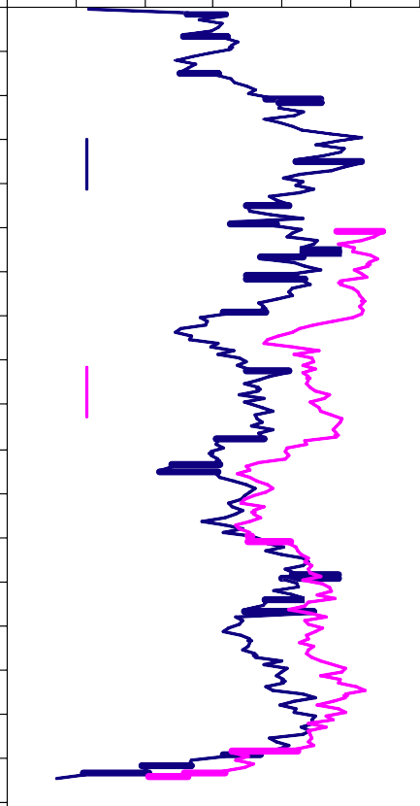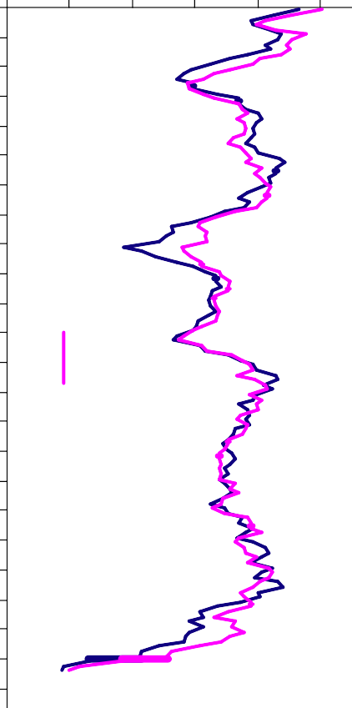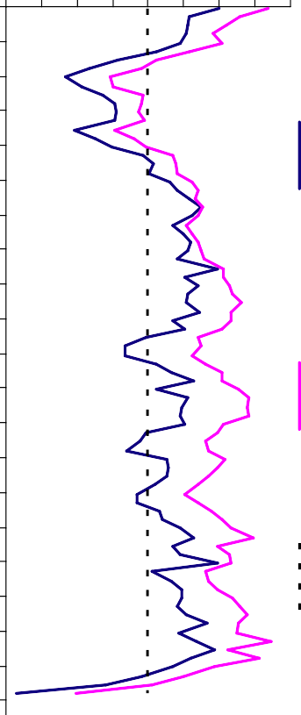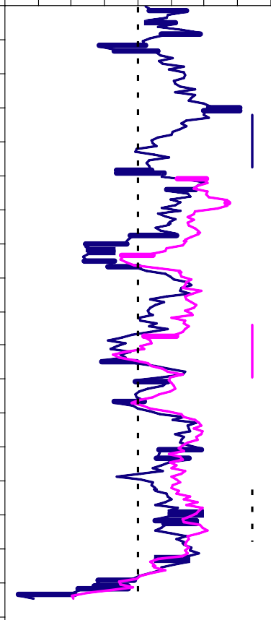

**Chart 1: CIPS Employment Surveys**

Index 60

Temporary

Manufacturing

Services

Source: CIPS

**Chart 3: BCC Employment Intentions Survey**

Manufacturing

Services

no change

Services

no change

60

55

50

45

40

35

30

Source: CIPS

Oct-97 Apr-98 Oct-98 Apr-99 Oct-99 Apr-00 Oct-00 Apr-01 Oct-01 Apr-02 Oct-02 Apr-03 Oct-03 Apr-04 Oct-04 Apr-05 Oct-05 Apr-06 Oct-06 Apr-07 Oct-07 Apr-08 Oct-08 Apr-09

## Chart 5: BoE Agents’ Scores for Investment Intentions

Agents'

Scores Manufacturing Services zero 4.0

3.0

2.0

1.0

0.0

-1.0

-2.0

-3.0

-4.0

Jul-97

Jul-98

Jul-99

Jul-00

Jul-01

Jul-02

Jul-03

Jul-04

Jul-05

Jul-06

Jul-07

Jul-08

Jul-09

## Chart 6: UK GDP Level

GDP: peak in output = 100

100



1973

1980

1990

2008

99

98

97

96

95

94

93

Source: Bank of England

## Chart 7: Real-Time Consensus Forecasts for UK GDP

1990 1991

% change 1992 1993

oya 1994 Final Outturns



5 Real Time Zero 4



3

2

1

0

-1

-2

-3

0 1 2 3 4 5 6

Source: Bank calculations

## Chart 8: Real-Time NIESR Forecasts for UK GDP

Percentage change on year earlier

5



1994

1992

1990

1993

1991

4

3

2

1

0

-1

-2

-3

1989 1990 1991 1992 1993 1994

1989 1990 1991 1992 1993 1994 1995

Source: Consensus

Year forecast made in

## Chart 9: Real-Time OECD Forecasts for UK GDP

1994

## Chart 10: BoE Agents’ Scores for Spare Capacity Within Firms

Agents'

5 Scores Manufacturing Services zero

4 4.0

3 3.0

1990

1992

1991

1993

2.0

2

1.0

1

0.0

0

-1.0

-1 -2.0

-2 -3.0

Jan-98

Jan-99

Jan-00

Jan-01

Jan-02

Jan-03

Jan-04

Jan-05

Jan-06

Jan-07

Jan-08

Jan-09

-3

1989 1990 1991 1992 1993 1994

## Chart 11: Inflation Expectations and CPI Inflation

CPI inflation (LHS) BoE/NOP (LHS)

Citi (LHS) YouGov Alpha (LHS)

Survey

Source: Bank of England

## Chart 12: Inflation Expectations vs Perceptions

6

perceptions, percentage points

Per cent 6

Barclays BASIX (LHS) GfK/NOP (RHS)

Balance

100 5

2008 Q4

90

5

4

3

80 4

70

line of best fit

60

50 3

40

2 30 2

1 20

10 1

0 0

expectations, percentage points

Jan-03 May-03 Sep-03 Jan-04 May-04 Sep-04 Jan-05 May-05 Sep-05 Jan-06 May-06 Sep-06 Jan-07 May-07 Sep-07 Jan-08 May-08 Sep-08

Jan-09

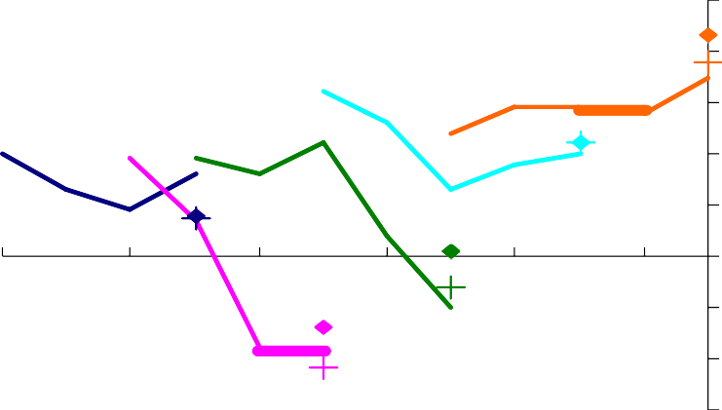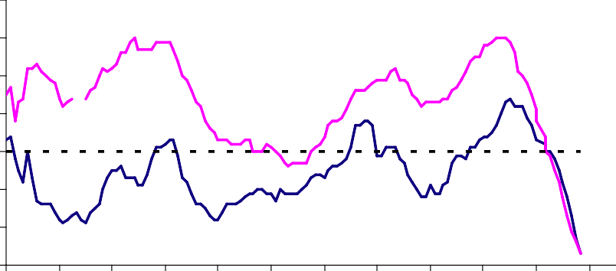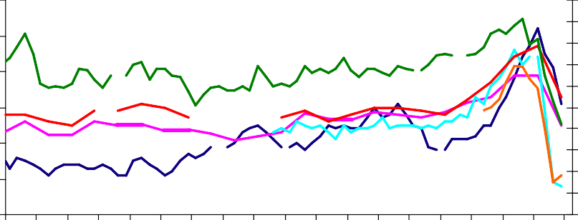

Source: Bank of England, ONS, NOP, and GfK

0

0 1 2 3 4 5 6

Source: Bank of England/NOP, Bank calculations

20



Jan-00

Jan-01

Jan-02

Jan-03

Jan-04

Jan-05

Jan-06

Jan-07

Jan-08

Jan-09

**Chart 13: Annual wage growth**

Per cent 8

AEI

AWE

7

6

5

4

3

2

1

0

Source: ONS

21